**@MutationTesting3**

According to my opinion,

This **@MutationTesting3** code shows approximately 75% **equivalent** to the Original Source Code.

**Difference between Original and MutationTesting3 codes output are showing below:**

Output of **MutationTesting3** Source Code:

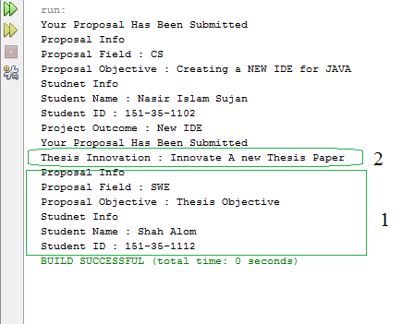

Figure 1 Output of MutationTesting3

**Output of Original Source Code:**

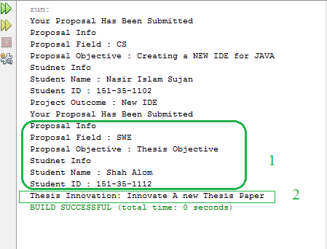

Figure 2 Output of Original Source Code